International Dimensions
Three School Collaboration, Friday 9th June 2023
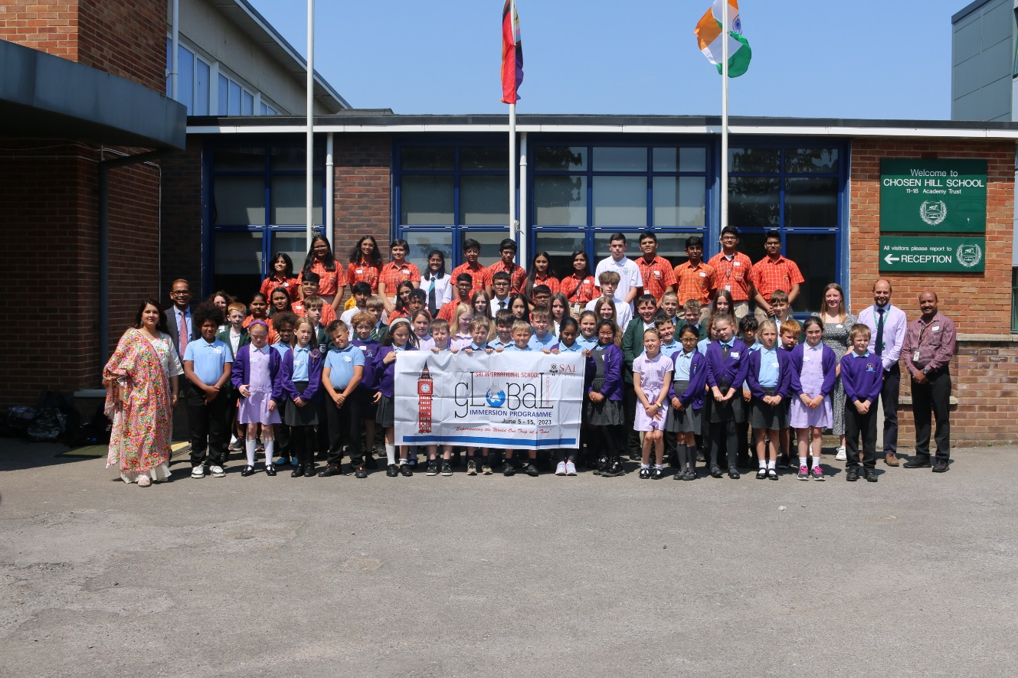

Pupils and staff from Chosen Hill School, Parton Manor Primary School and SAI International pose for official International Dimensions Day photo outside Reception.

On Friday 9th June 2023, Chosen Hill School was proud to host visitors from both our British Council international partner school in India, SAI International, and Parton Manor Primary School, Churchdown.

Over 70 students, from Years 6 – 13, and 9 staff, from the 3 schools took part a range of International Dimensions Projects throughout the day.
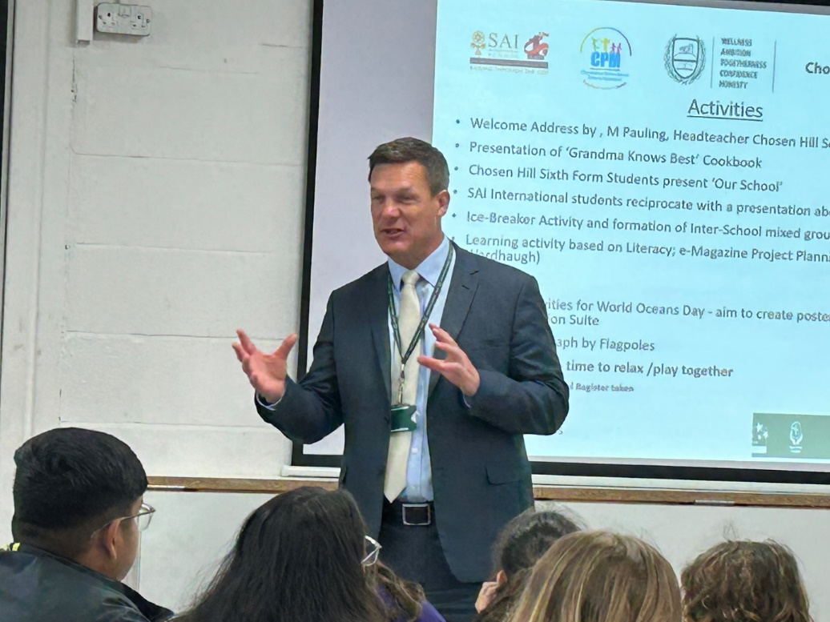

Mr. Pauling welcoming our guests.

Mr. Pauling, Headteacher of Chosen Hill School, formally welcomed everyone to the event and was joined by Mr. Prakash Sahoo, Headteacher, SIA International Secondary School, Orisha, India, and Mrs. Jenny Hennett, International Dimensions Lead from Parton Manor Primary School, Churchdown.

The objectives of the day were all based around our on-going work aimed at continuing the process of building strong bonds between the 3 schools, understanding what we have in common and our differences, celebrating the completion of collaborative projects, and to start the planning for exciting joint e-magazine project.

The event was hosted in the Lower School Hall where students from each of the three schools were mixed together to form a number of groups that were hosted by a Chosen Hill School Sixth Form International Dimensions Ambassador.
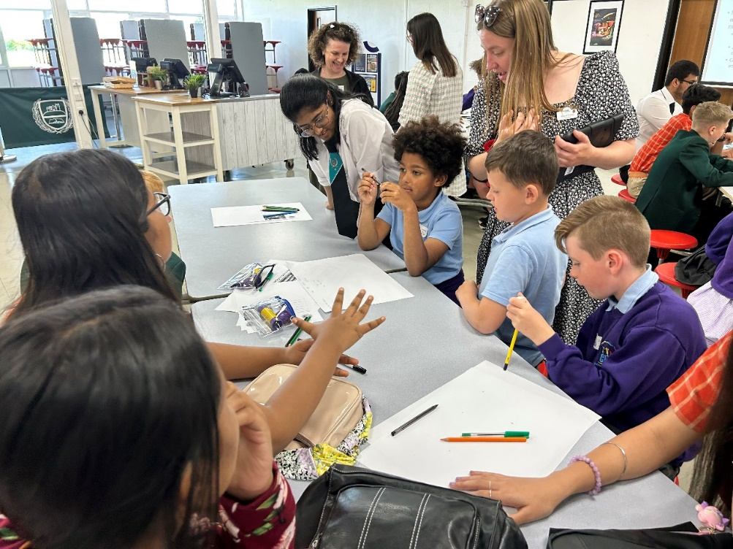

Pupils form all three schools work collaboratively on international projects during the day.

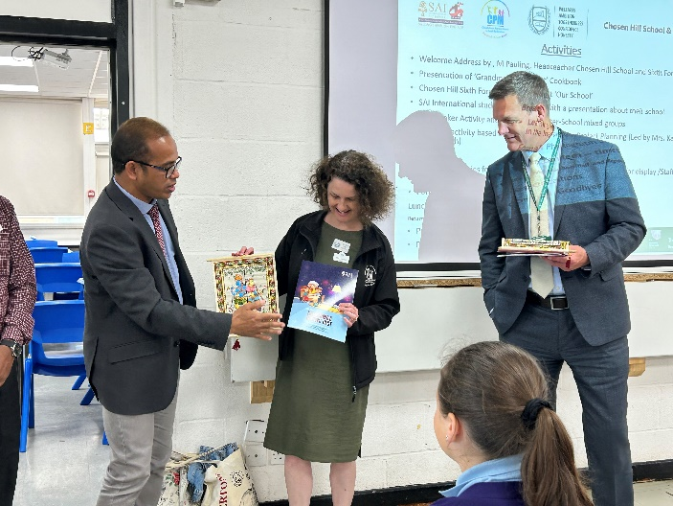
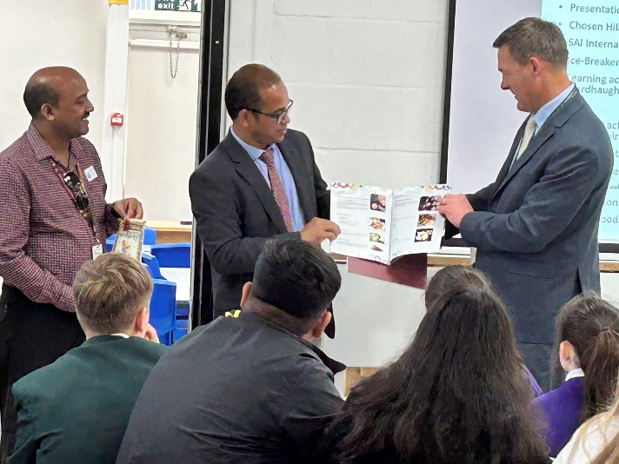
After the formal welcomes, we celebrated the publication of the ‘Grandma Knows Best’ cookbook. An international collaborative project, involving pupils from all three schools, helping them to learn about differences and similaries between our cultures.

Mr. Prakash Sahoo, Headteacher, SIA International Secondary School, India, presenting the completed ‘Grandma Knows Best’ cookbook to Mr. Pauling and Mrs. Hennett.

Next, students made presentations to each other about life at their respective schools.
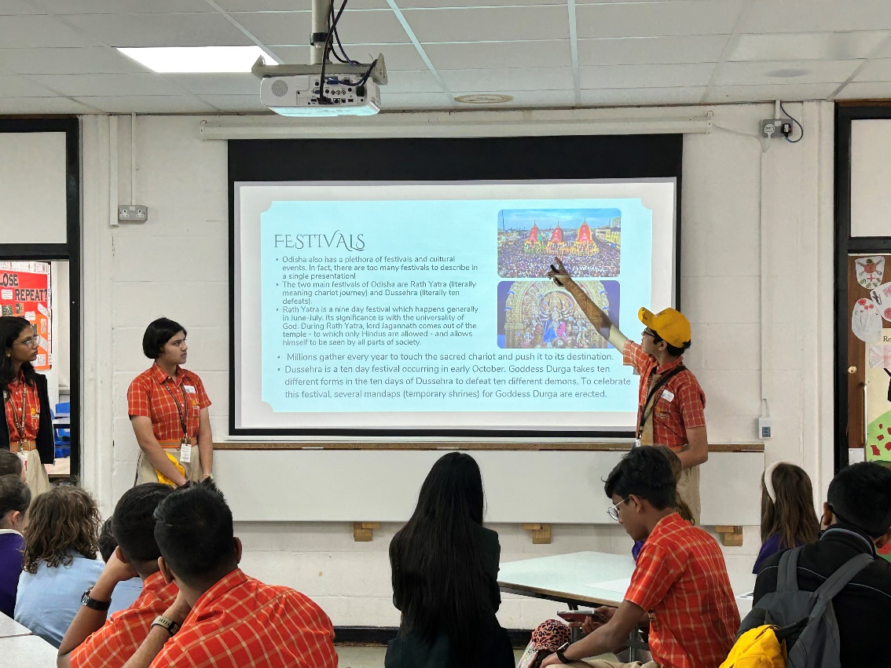

Pupils from SAI International School, India, presenting about life at their school and living in India.

The groups then participated in the initial planning or our new and exciting 3-school collaborative project – an e-magazine.

After a short break, the students returned to a collaborative project exploring the issue of plastic pollution in our oceans, and what they can personally do to help contribute towards a solution to the problem. Each student gave a pledge to do something differently to help keep our oceans plastic free.
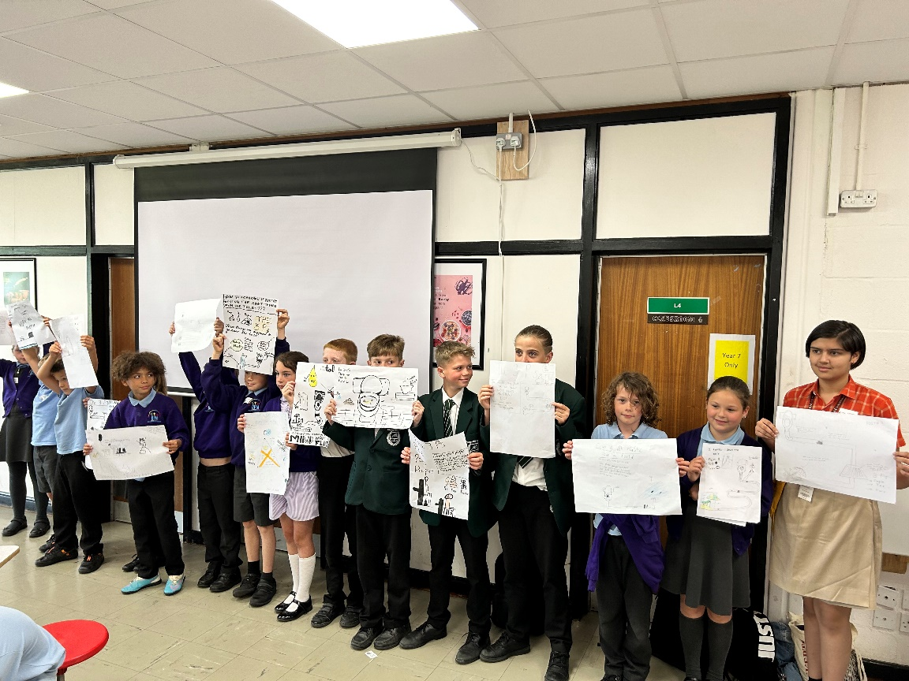

Pupils from all 3 schools show off their poster designs ready for use as part of a collaborative information campaign to help reduce plastic pollution in our oceans

During and after lunchtime, the students had time to share email and social media addresses with each other to enable them to develop and nurture the friendships made during the event.

To finish off the day a group photo was taken, and our Sixth Form ambassadors waved off our visitors.

The day was a great success and our students commented, ‘I really enjoyed meeting and working with them…’, ‘I was impressed at how hard they worked on the learning activities,’

Mr. Sahoo, also formally invited Chosen Hill School to visit SAI International School next year and some of our students commented on this by saying, ‘I can’t wait to visit their school.’
So look out for some exciting news about this early next academic year.

I Bird
International Dimensions Lead
Chosen Hill School

