Chosen Hill School Receives Recognition for Its Outstanding International Dimension to Learning
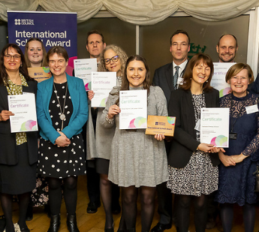

Mr. Bird, International Dimension Lead, (second from right), to the left of Scott MacDonald, Chief Executive of the British Council, receiving the International School Award Plaque and Certificate on Behalf of Chosen Hill School at The Houses of Parliament, Monday 20th March 2023.
Despite the numerous restrictions caused by the Covid-19 Pandemic, students and staff at Chosen Hill School have found many innovative ways to both keep existing relationships going and to develop new international partnerships over the last 2 years. We have kicked started many of our ongoing collaborative projects, acted in an ambassadorial role for one of our feeder primary schools, Parton Manor Primary, and introduced a number of new and exciting projects across all year groups. Furthermore, the School has also re-started its International Dimensions Club and has recently appointed five new Sixth Form Student Ambassadors to promote, lead and manage a range of international activities throughout the school and our wider community.
As a result, the British Council have recognised our outstanding International Dimension to learning here at Chosen Hill School, one that continues to develop and improve as more and more faculties embark on exciting collaborative projects, visits and learning activities with schools from India, Germany, France and Malawi, to mention but a few.
Please continue to encourage your child to get involved in these activities.
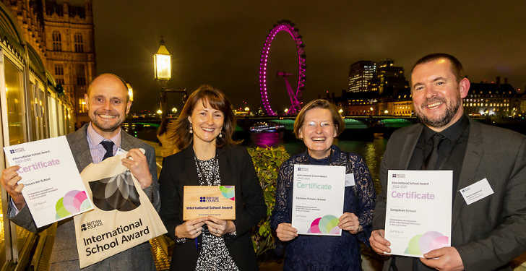

Mr. Bird, (first left), with Colleagues from Schools based in Coventry on the Terrace at the Houses of Parliament.

