International Dimensions Activity/Project Media Briefing
(When complete, please mail to IB/SJ so Social Media/Bulletins/ID Website can be updated)
Field | Details
Activity: | International Remembrance Week Assemblies
Date: | 11th November 2022
Image: | 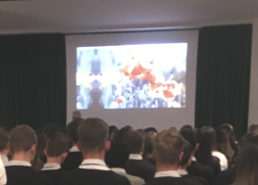
Students involved: | Whole School
Objectives: | When the First and Second World Wars took place  Why November 11th is known as Remembrance Day and how it is marked  Why we wear a poppy  Appreciate the diversity of the meaning of the day  To raise funds to support the work carried out by the Royal British Legion.
Summary of Tasks (what students and staff did) | The school ran a series of assembly presentations lead by Mr. M. Day and Mrs. S. Thomas using a video, created in house, alongside videos provided by the Royal British Legion.  Mr. Lewis was included in the recordings, playing the Last Post.  A reading of the poem ‘In Flanders Fields, by John McCrae, 1872-1918, was recited by the Head Boy, Matthew Gore, and Head Girl Hiva Hesso.
Learning Outcomes: | Explain when the events being remembered on Remembrance Day happened  Explain what happens on Remembrance Day and why this takes place around November 11th  Give reasons why Remembrance Day occurs and is important to many people.  To inform students that people are still getting injured and killed protecting us.  Lest we forget!!  We are so proud of all of our students as they were reverent and respectful throughout.
Student quotes:
Author: | CJ/MD/ST/KN/TR/IB

