Re-launch of the International Club
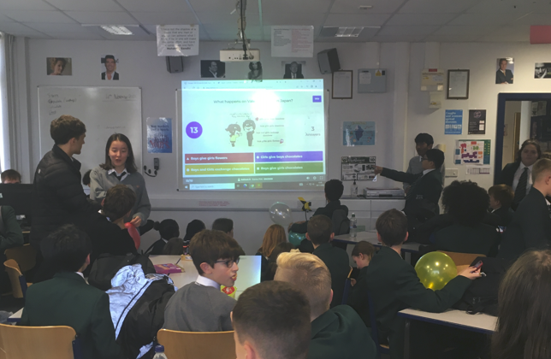
Friday 4th November 2022

It was amazing to see so many students at the International Club’s re-launch, in classroom G20, during lunchtime on Friday 4th November. Students took part in a quiz all about Japan as we had visitors from Shukutoku Sugamo Senior High School, Tokyo on that day. The competition was fierce and the excitement in the room, palpable.

The aim of the club is to educate our KS3 students about the global environment, and to foster cooperation, understanding and acceptance of diversity. It is also an opportunity for students to give back to Chosen Hill School and our wider global community. So, it is more about giving than receiving - although attendance, hard work and achievement will be recognised through house points, awards and special commendations for celebration assemblies.

Going forward, the club has 6 main areas of work that students can chose from:
- Fundraising for our ongoing Thanthwe Primary School, Malawi, Classroom Building/Pen-pal Projects,
- Weekly Just for fun – international quizzes, competitions etc.,
- Learning how to do website design and then reporting on international matters via the School’s International web page,
- Working on collaborative projects (set up by individual subject teachers) that are being organised with or Partner Schools in Germany, India and Japan,
- Planning and preparation for whole school International activities, house competitions, and fundraising to subsidise future partner school visits.
- Global warming and how we as a school community can cut down waste, pollution and emissions.
We are also open to new ideas, because the club is run by our Sixth Form International Student Ambassadors, Ryan Nash and Christy Reji, for our younger KS3 students and we want it to focus on issues relevant to them.

All students in Year 7, 8 and 9 are welcome but numbers may have to be limited, so why not come along each Friday lunchtime 1:30 – 2pm, G20. Therefore, if you are interested in joining and didn’t come along last Friday, please contact Mr. Bird, International Dimensions Lead, Chosen Hill School, using IB@chosen-hill.gloucs.sch.uk

