German Visitors at Chosen Hill School on 19 October 2022
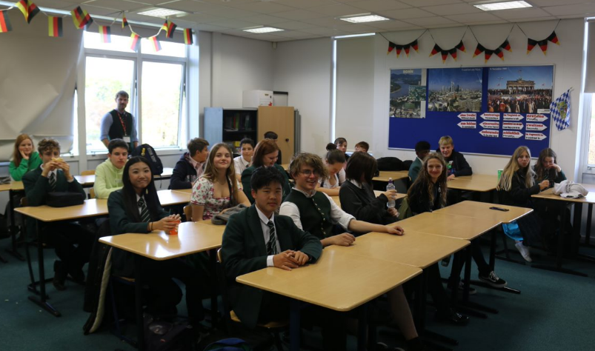
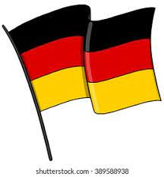

We had the pleasure of hosting 14 students and two members of staff, Frau Elisabeth Schick-Billy and Sebastian Wilhelm, from our partner school, Oberland Realschule in Holzkirchen, Germany, at Chosen Hill School this week. The students were paired up with some of our year 9 German learners who took them to their lessons. Break and lunchtime were a great opportunity to connect further and make new friends. We heard everything about their school and area where they come from in a presentation by two of the German guests. Holzkirchen is a town near Munich in the South of Germany close to the Bavarian Alps.
A huge thank you goes to all the lovely year 9 hosts and all the colleagues at Chosen Hill School who made our visitors feel so welcome. Vielen Dank!
Future projects will include pen-pals and visits to their school. Our first visit is scheduled for July 2023. All year 8, 9 & 10 German leaners have been invited to the Munich/Holzkirchen trip and there is one last chance to sign up for it. The letters have gone out on Schoolcomms. If you haven’t received it and you wish your son/daughter to go, please contact Mrs Smith (csm@chosen-hill.gloucs.sch.uk). There are a few more spaces!
Mrs Bernhuber

