Step into Sixth Form Bridging the Gap from Year 11 to Sixth Form

Bridging work  PEARSON BTEC LEVEL 3  Information |  | 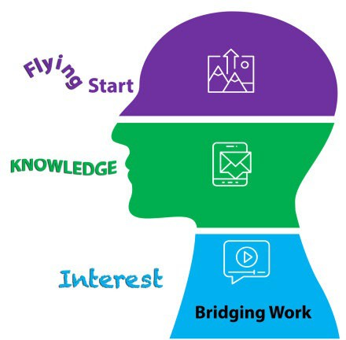 |  |   Remember, as an independent learner you should still be taking notes and keeping your work in an organised fashion. Don’t stop exploring ideas and additional themes around the topics, just because you now have set tasks that will be submitted for assessment.
Technology  Mr Taylor    lta@chosen-hill.gloucs.sch.uk |  |  |  | The purpose of these Bridging tasks is to spark your continued interest in the subject, develop your knowledge and prepare you for a flying start in September, enjoy them!  Note the submission dates and method for every subject.
Skills | Compulsory  Tasks |  | Outcome |  | Assessment method | Submision date
  Reading      Internet Research Accurate writing | Reading: http://www.carnegiecyberacademy.com/facultyPages/environment/iss ues.html  https://edinburghsensors.com/news-and-events/impact-of- technology-on-the-environment-and-environmental-technology/  Complete the BTEC ICT Step 3 Bridging task document and email it to Mr Taylor.  Both questions are essay based questions and Task 1 should be roughly two pages of A4 and Task 2 one page of A4. |  | Students will gain a greater understanding of the impact of Information Technology on the environment. |  | Completion of Worksheet 2 Global and environmental issues. | September 16th 2024  Via email to lta@chosen-hill.gloucs.sch.uk
Completing work by the deadline | Optional: https://www.bbc.co.uk/bitesize/guides/zvff3k7/revision/1  https://www.bbc.co.uk/bitesize/guides/zvff3k7/test |  | Students will gain a brief understanding of the laws, ethics and environmental issues associated with IT. |  | Print screen your test scores and email them to lta@chosen-hill.gloucs.sch.uk | September 16th 2024  Via email to lta@chosen-hill.gloucs.sch.uk


